Dear Wade Hampton Property Owners,

With our 2020 season underway, there are a few things we’d like to share with you.

NORTHLAND COMMUNICATIONS.  Working to bring greater stability and higher broadband speeds to Wade Hampton, Northland repaired and replaced portions of their existing cable plant over the winter.  They expected the project to be completed this spring.  However, it became apparent that the winter work did not suffice and additional sections needed to be replaced. We are working with Northland’s Regional Director of Technical Operations, who is now overseeing the work currently being done.  That work will continue through July with the goal that upgrades in speed will be available to Wade Hampton in August.  All of this work is at no cost to the POA or its members.

In the meantime, if you have issues with a slower-than-usual or intermittent signal, please contact me and I will work with Jerry Blackburn to get a visit scheduled.

CASHIERS GLENVILLE VOLUNTEER FIRE DEPARTMENT.  Thank you for your votes supporting the proposed Amendment to the POA Declaration of Protective Covenants.  Its adoption allows the Cashiers Fire Department to locate a sub-station on lot S8 A on our southern boundary with the attendant benefits to our members.  This summer, the POA will work closely with the Fire Department on this project.

DECK AND PORCH SCREENING.  Lately, several homeowners have considered installing automatic plastic screens to protect furnishings on their decks and porches.  Although there are no prohibitions regarding such screens, members and their contractors should be aware that the requirement for POA Design Committee approval depends upon where the screen is located.

* Plastic screens affixed to the inside walls of decks and porches do not require Design Committee approval.  Often, but not always, such screens are installed behind insect screens that also protect the porch.
* Plastic screens affixed to the exterior of a home or other building result in a change in the exterior appearance and, as a result, do require prior Design Committee approval.  Here, the Design Committee, will maintain a preference for exterior tracks and storage apparatus to be dark in color.  Additionally, as with window trim, there is a requirement that no white or other light-colored tracks or other trim can be approved if visible from the golf course.

SIGNAGE.  This exceptionally wet spring has caused many of the Wade Hampton road and 991 signs to darken.  Steve Queen has identified products and a process to improve their look and legibility.  Over the summer, we will be applying this process to signs throughout the community.

SPEEDING.  Once again the POA is receiving reports of vehicles personal and commercial vehicles  exceeding safe speeds on Wade Hampton roads.  This time of year many residents are out walking, so everyone needs to carefully monitor their own speed and remind family and friends to do the same.  Please manage speeds entering and exiting both gates.  And if you experience a dangerous driver and can report a license plate to the POA, that driver will be contacted.

991 CALLING IN CASHIERS.  This important information was provided to us by Vision Cashiers:

Most people think that their cell phone automatically adjusts their location for 911 to where they are, and this is **NOT true**. Below are instructions on how to edit this for an iphone (it is probably similar on all cell phones). Any time you change your location, especially to your second home or back, you must manually change the 911 access location. Please do this now so that you are prepared “when seconds count”.  Follow these 4 steps:

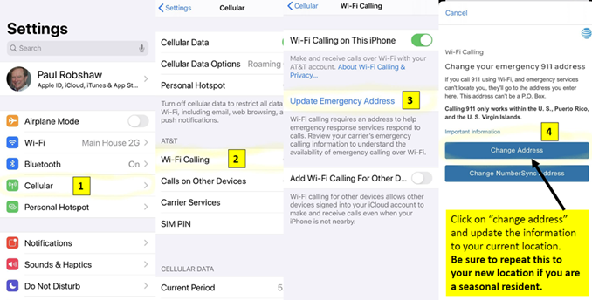

We thank everyone for their attention to these matters, and look forward to hearing from you if we can be of help in any way this summer!  
  
Best from the POA team,

Sandy

Sandy Hardy

Administrator

Wade Hampton Property Owners' Association

P.O. Box 2286

Cashiers, NC 28717

828-743-9895